The first databaseprogram
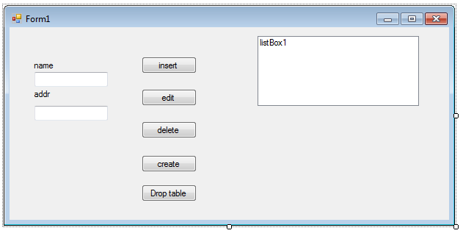

using System;
using System.Collections.Generic;
using System.ComponentModel;
using System.Data;
using System.Drawing;
using System.Text;
using System.Windows.Forms;
using System.Data.Odbc;

namespace fall2015windb01
{
public partial class Form1 : Form
{
static public string sql;
static public string constr = "dsn=yourdsn; name=root; pwd=";
static public OdbcConnection con;
static public OdbcCommand cmd;
static public OdbcDataReader rd;
static public int[] ind = new int[100];

public Form1()
{
InitializeComponent();
updlb();
}

public void updlb()
{
int x = 0;
listBox1.Items.Clear();
sql = "SELECT * FROM firstone;";
dbr();
while (rd.Read())
{
listBox1.Items.Add(rd["name"].ToString());
ind[x++] = Convert.ToInt16(rd["i"]);
}
rd.Close();
}

private void dbw()
{
con = new OdbcConnection(constr);
cmd = new OdbcCommand(sql, con);
con.Open();
cmd.ExecuteNonQuery();
con.Close();
}

private void dbr()
{
con = new OdbcConnection(constr);
cmd = new OdbcCommand(sql, con);
con.Open();
rd = cmd.ExecuteReader();
}

private void button1_Click(object sender, EventArgs e)
{
//create table
try
{
sql = "CREATE TABLE firstone ( ";
sql += "i int primary key auto_increment, ";
sql += "name varchar(30), ";
sql += "addr varchar(40));";
dbw();
}
catch
{
}
}

private void button2_Click(object sender, EventArgs e)
{
//insert
sql = "INSERT INTO firstone (name, addr) VALUES ('";
sql += textBox1.Text;
sql += "','";
sql += textBox2.Text;
sql += "');";
dbw();
textBox1.Text = "";
textBox2.Text = "";
updlb();
}

private void listBox1_SelectedIndexChanged(object sender, EventArgs e)
{
sql = "SELECT * FROM firstone WHERE i = ";
sql += ind[listBox1.SelectedIndex];
sql += ";";
dbr();
while (rd.Read())
{
textBox1.Text = rd["name"].ToString();
textBox2.Text = rd["addr"].ToString();
}
rd.Close();
}

private void button3_Click(object sender, EventArgs e)
{
//edit
sql = "UPDATE firstone ";
sql += "SET name = '";
sql += textBox1.Text;
sql += "', addr = '";
sql += textBox2.Text;
sql += "' WHERE i = ";
sql += ind[listBox1.SelectedIndex];
sql += ";";
dbw();
textBox1.Text = "";
textBox2.Text = "";
updlb();
}

private void button5_Click(object sender, EventArgs e)
{
//delete
sql = "DELETE FROM firstone WHERE i = ";
sql += ind[listBox1.SelectedIndex];
sql += ";";
dbw();
textBox1.Text = "";
textBox2.Text = "";
updlb();
}

private void button4_Click(object sender, EventArgs e)
{
//drop table
sql = "DROP TABLE firstone;";
dbw();
}
}
}

